|  |
| --- |
| CI6300 – INDIVIDUAL PROJECT |
| Uni-Hood Report |
| Appendix B: Screenshots |
|  |
| **Daniel Carnovale** |
| **23/04/2017** |

|  |
| --- |
|  |

Contents

Amazon Billing 4

bil-1 4

Creating and Associating Elastic IP to Instance 5

ela-1 5

ela-2 5

AWS Console for Mobile 6

aws-1 6

aws-2 7

aws-3 8

TortoiseGit for Windows 9

tor-1 9

tor-2 9

tor-3 10

tor-4 10

tor-5 11

tor-6 12

tor-7 12

tor-8 13

tor-9 14

tor-10 15

tor-11 15

tor-12 16

tor-13 16

OctoDroid 17

oct-1 17

oct-2 18

oct-3 19

SSH KeyPair Generation 20

key-1 20

key-2 20

Amazon EC2 Instance Creation 21

ec2-1 21

ec2-2 21

ec2-3 22

ec2-4 22

ec2-5 23

ec2-6 23

ec2-7 24

ec2-8 24

Setting up Putty and Encrypted PPK File 25

put-1 25

put-2 25

put-3 26

put-4 26

Connecting to the Instance 27

con-1 27

Creating / Removing EBS Volumes 28

ec2-9 28

ec2-10 28

ec2-11 29

ec2-12 29

Managing EBS Volumes 30

ec2-16 30

ec2-17 30

Installing Apache and PHP, and Managing the WebServer 31

pak-1 31

pak-2 31

Backup/Restore Test Data 32

bak-1 32

bak-2 32

# Amazon Billing

## bil-1

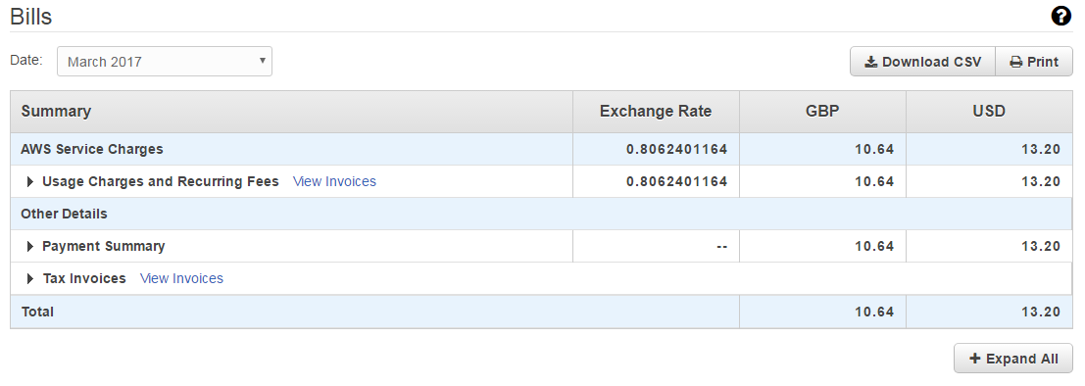

# Creating and Associating Elastic IP to Instance

## ela-1

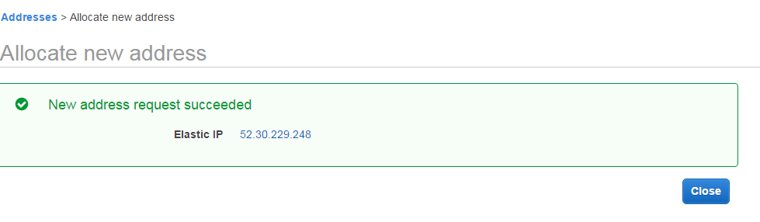

## ela-2

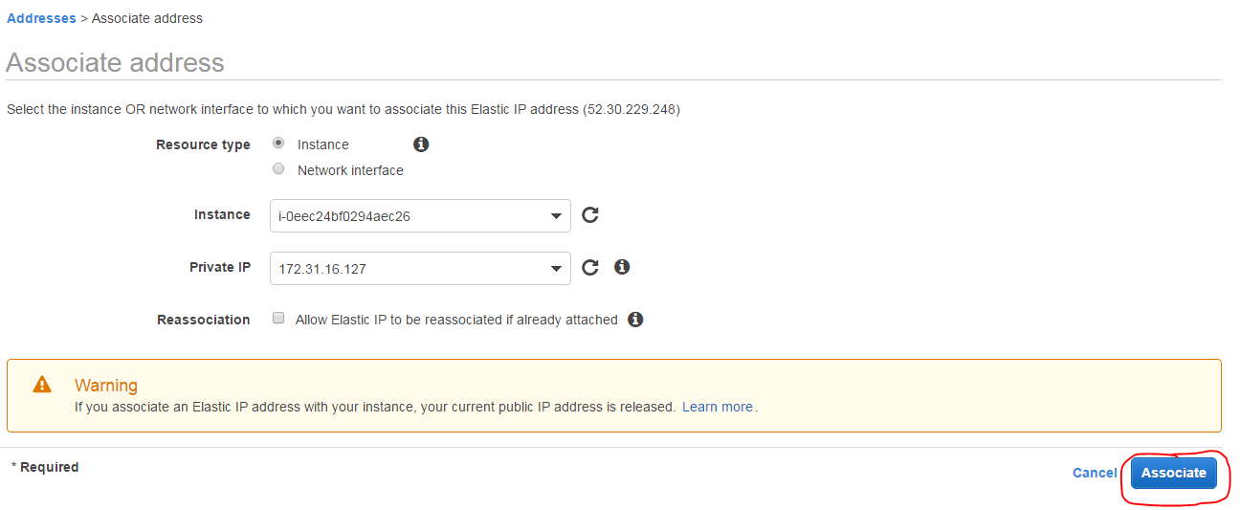

# AWS Console for Mobile

## aws-1

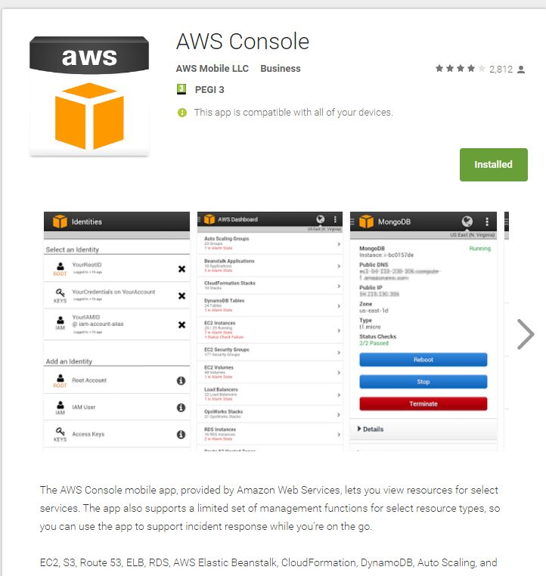

## aws-2

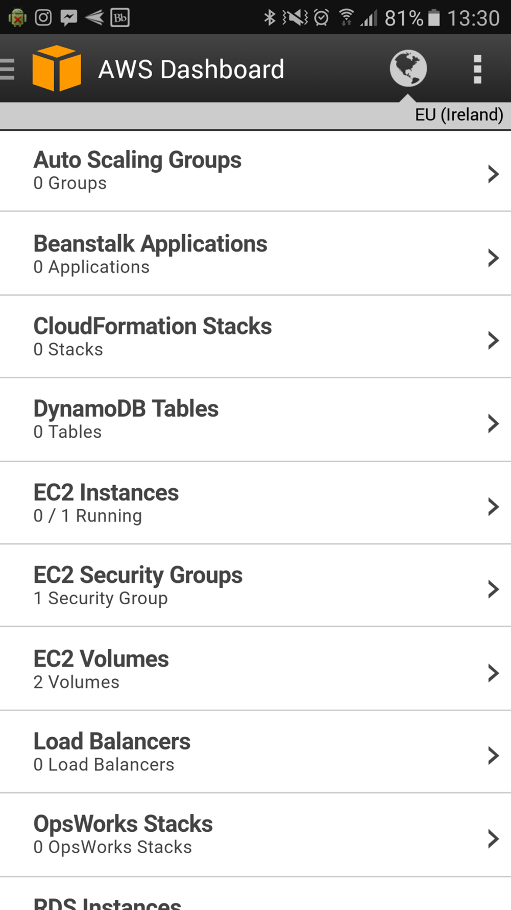

## aws-3

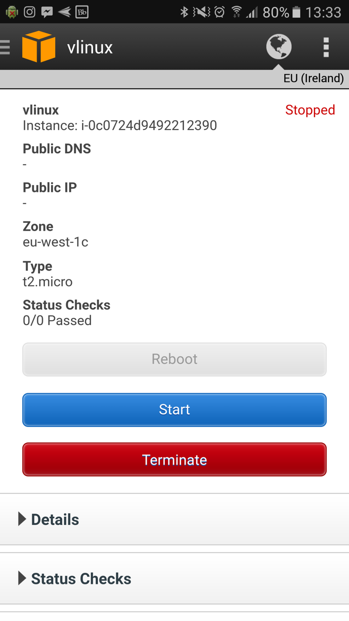

# TortoiseGit for Windows

## tor-1

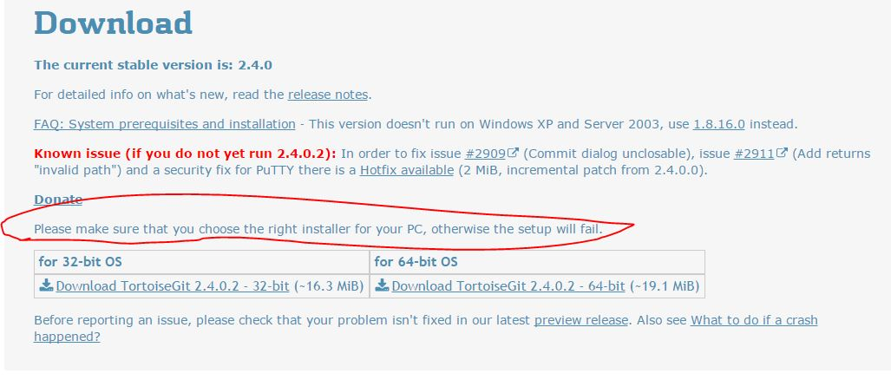

## tor-2

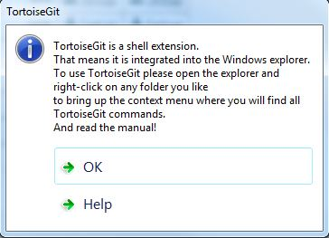

## tor-3

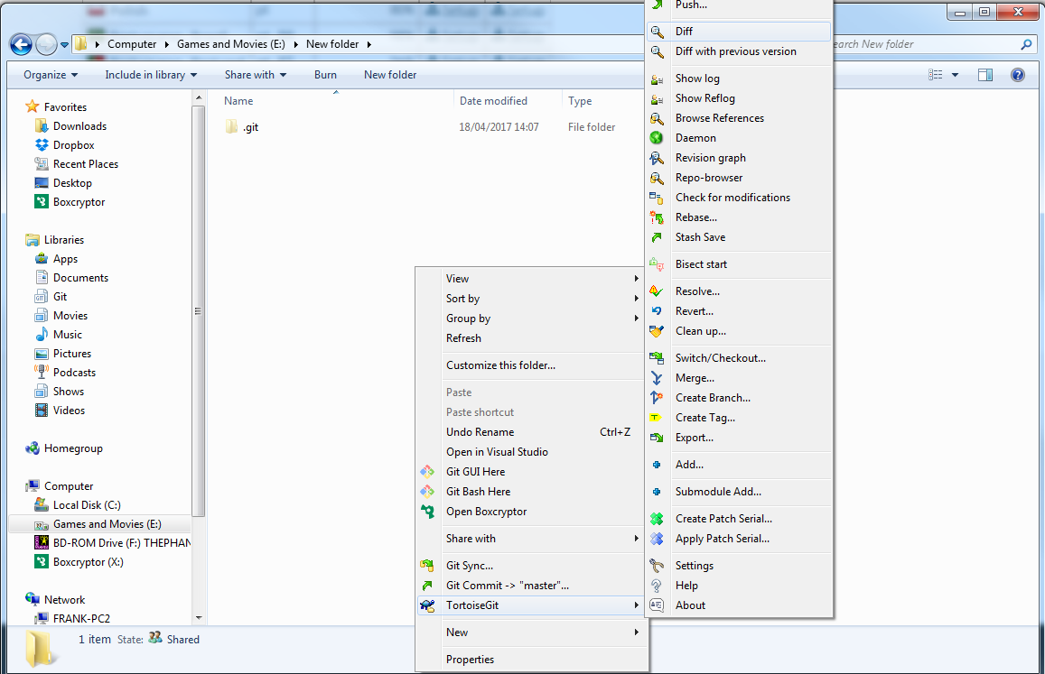

## tor-4

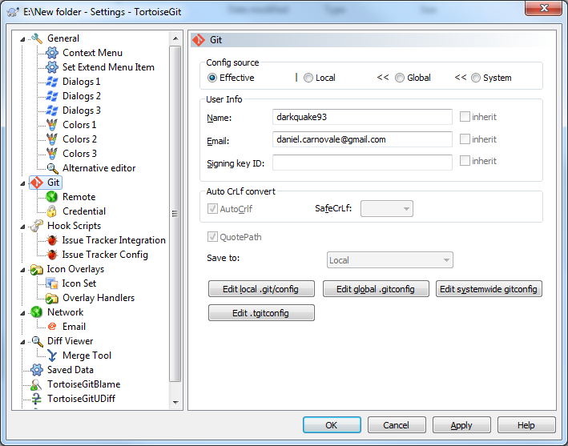

## tor-5

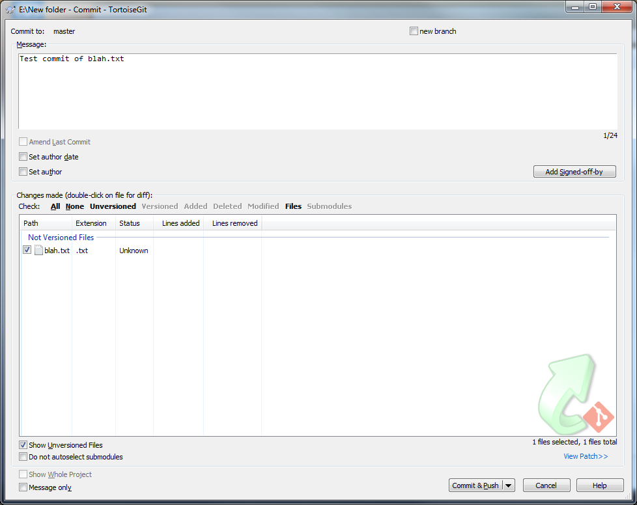

## tor-6

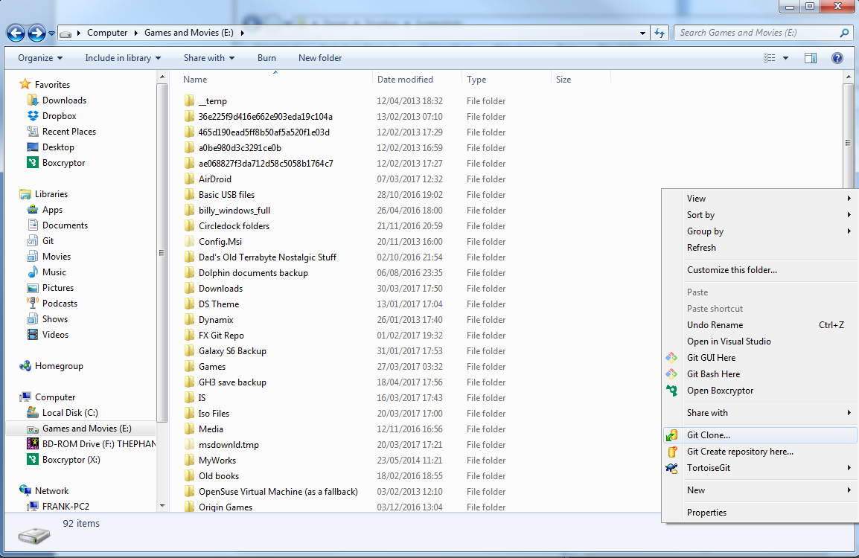

## tor-7

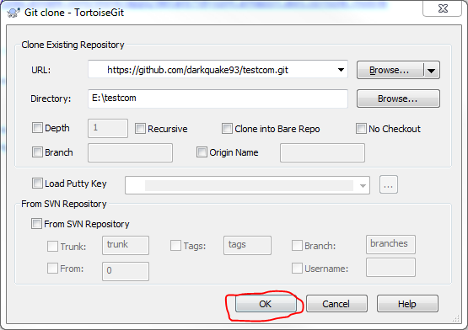

## tor-8

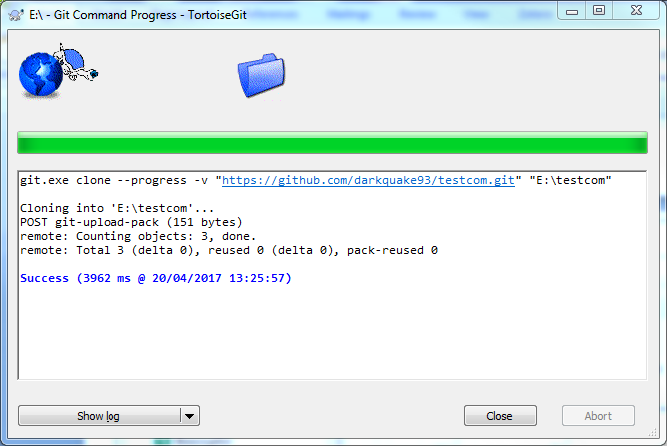

## tor-9

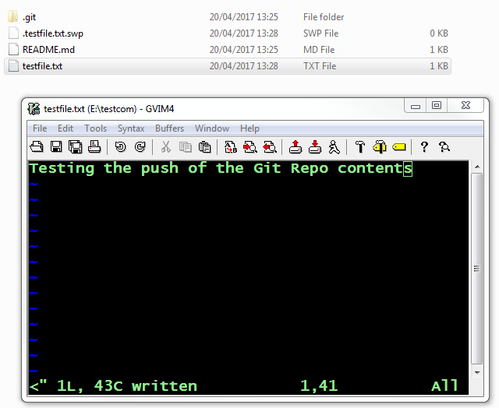

## tor-10

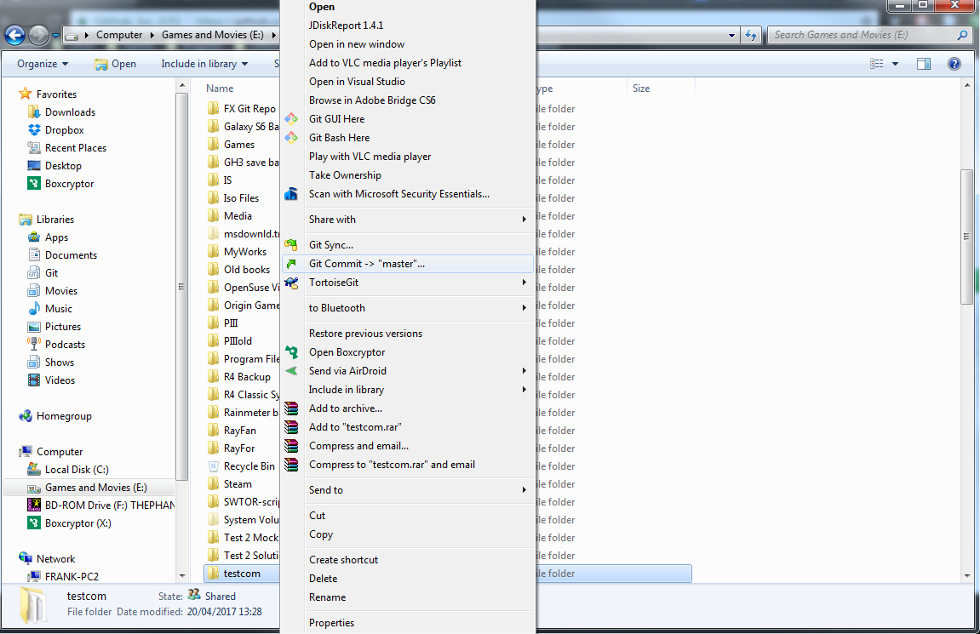

## tor-11

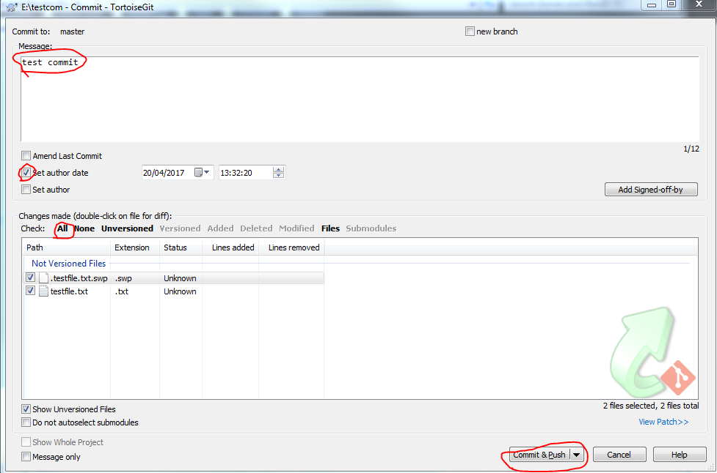

## tor-12

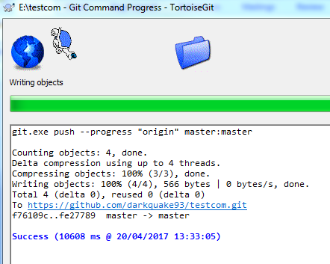

## tor-13

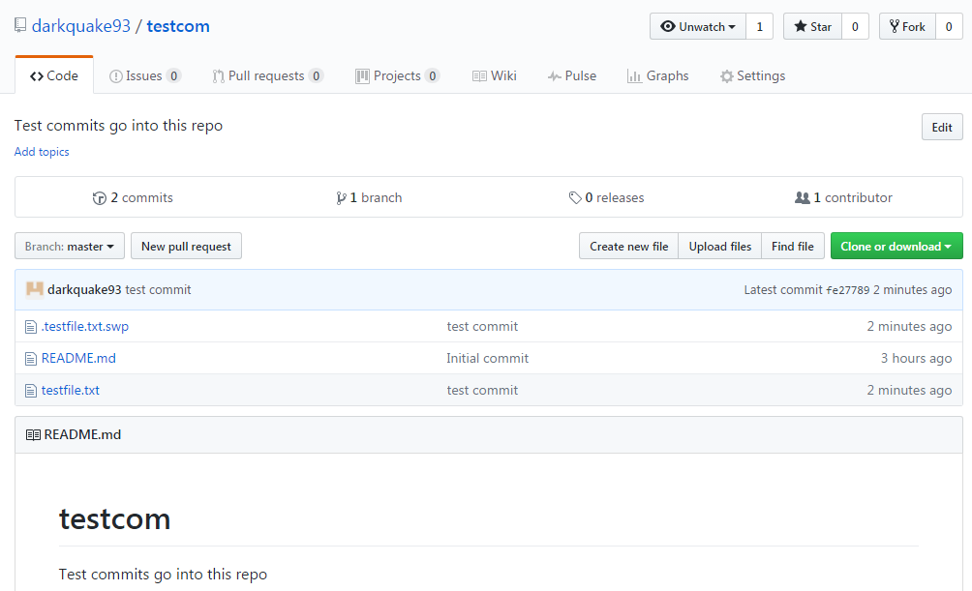

# OctoDroid

## oct-1

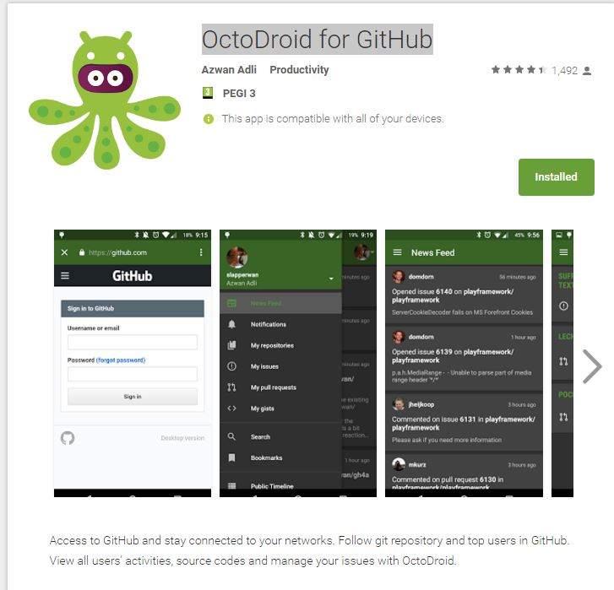

## oct-2

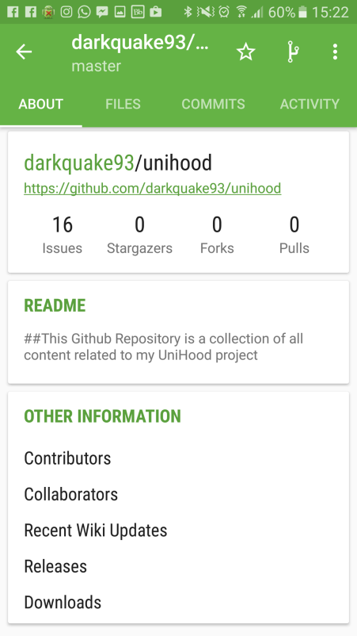

## oct-3

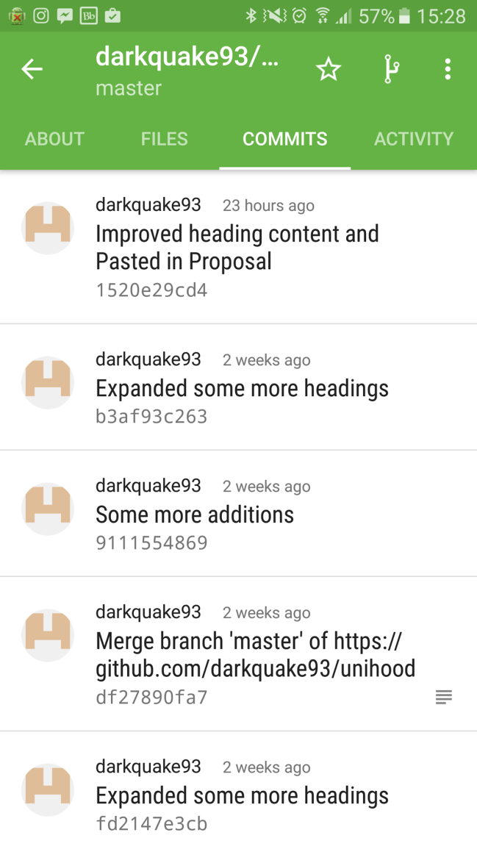

# SSH KeyPair Generation

## key-1

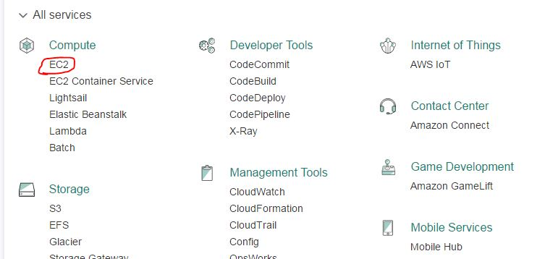

## key-2

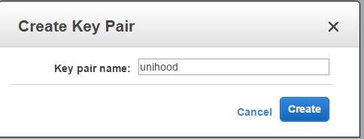

# Amazon EC2 Instance Creation

## ec2-1

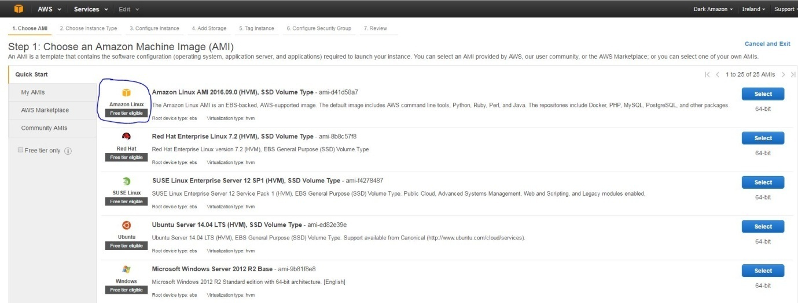

## ec2-2

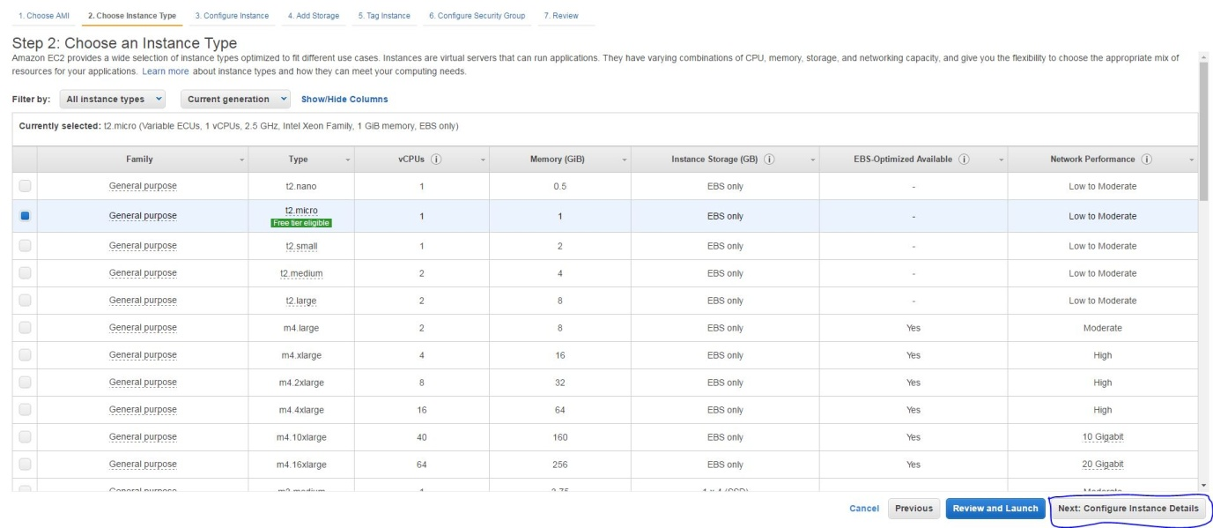

## ec2-3

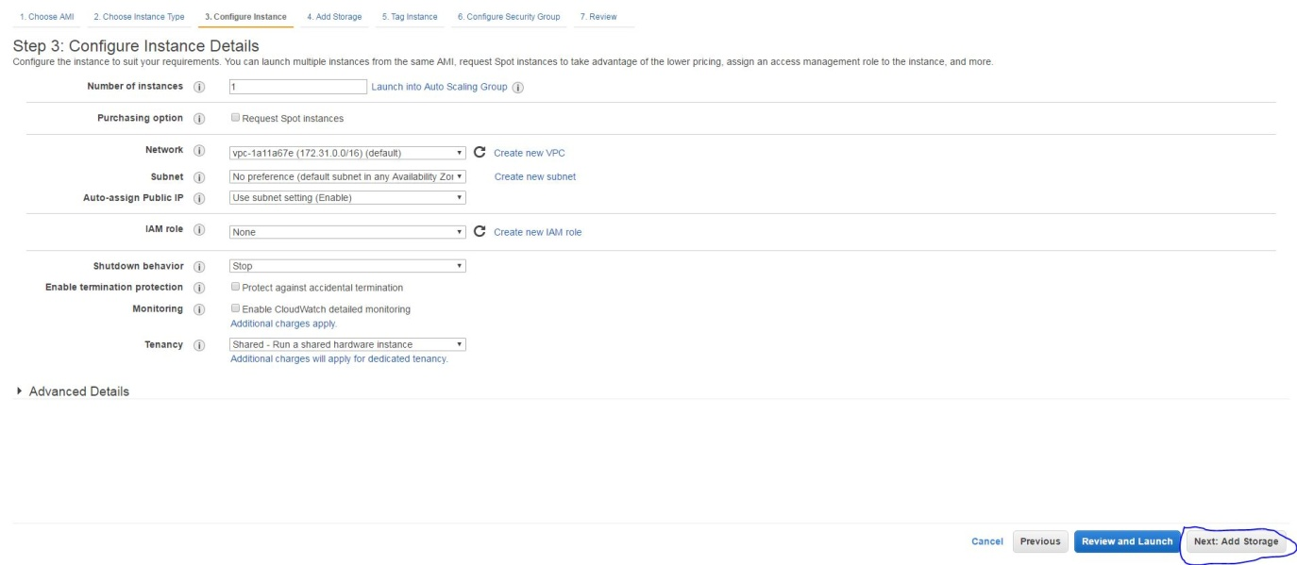

## ec2-4

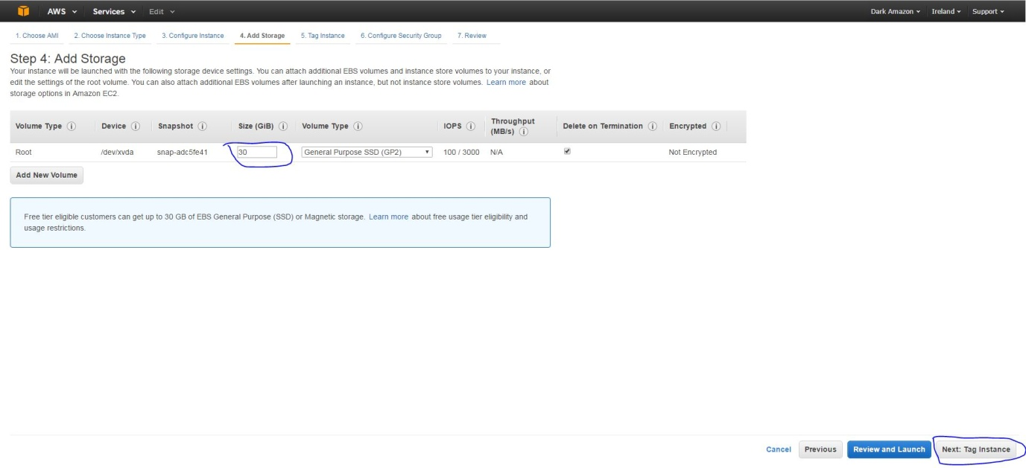

## ec2-5

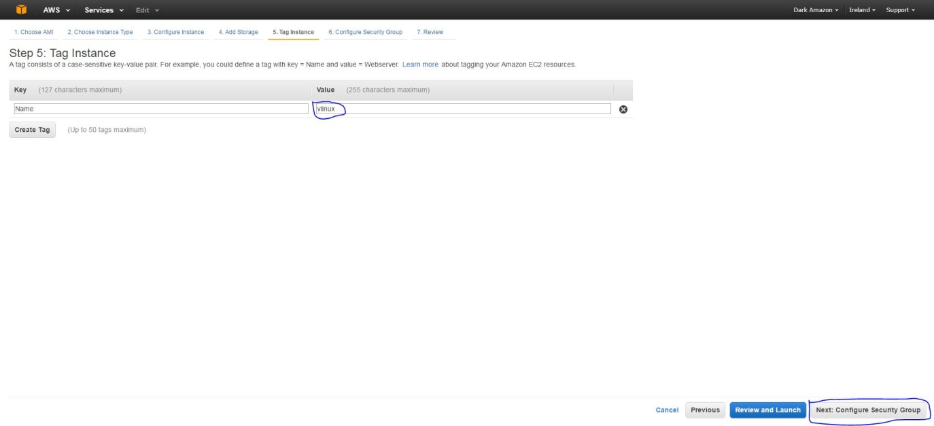

## ec2-6

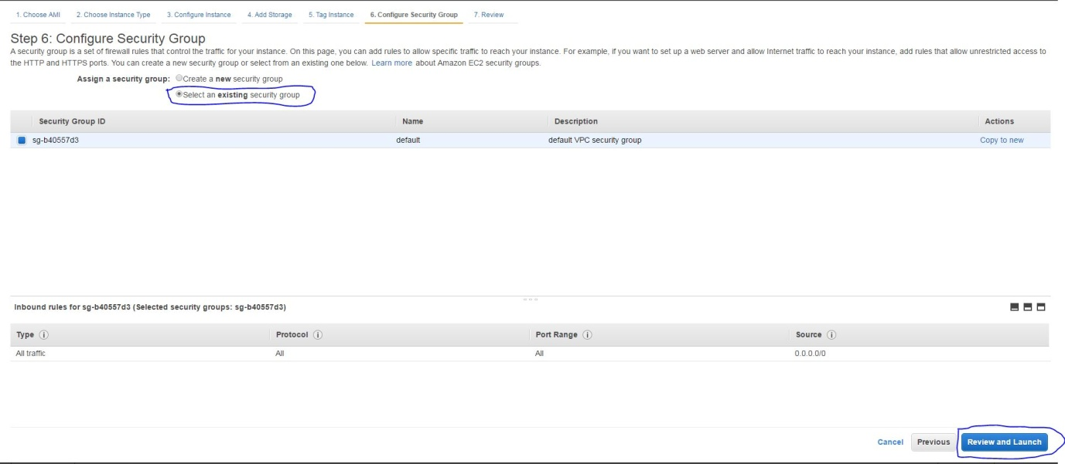

## ec2-7

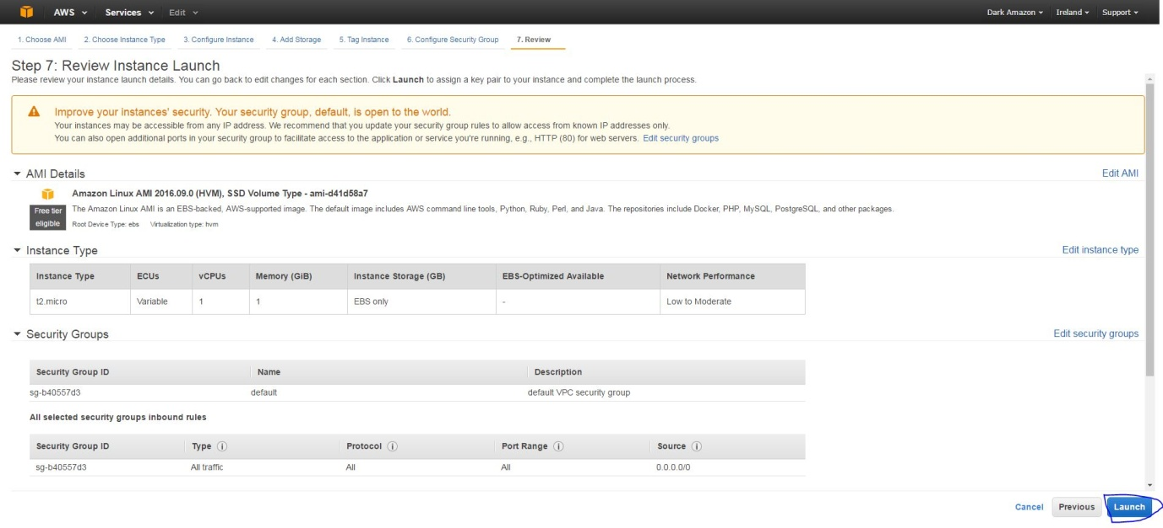

## ec2-8

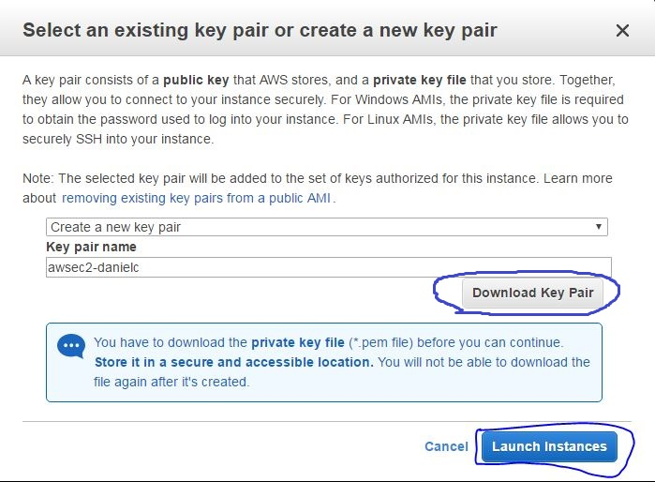

# Setting up Putty and Encrypted PPK File

## put-1

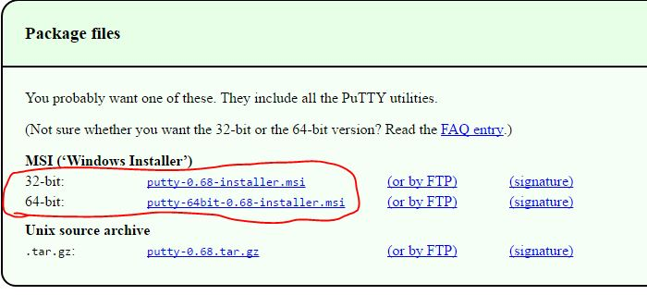

## put-2

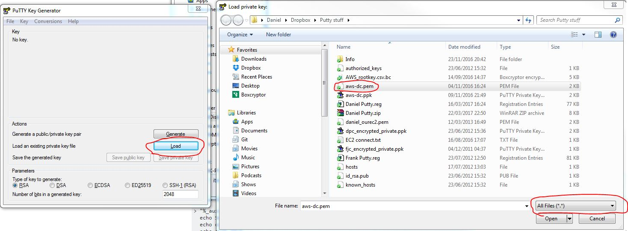

## put-3

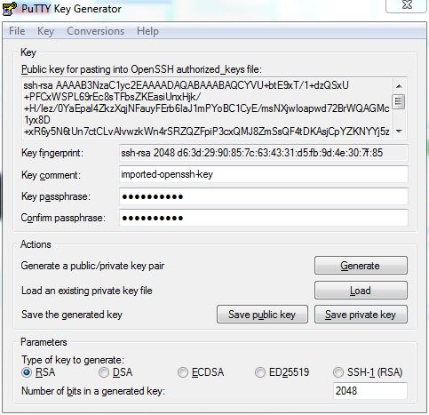

## put-4

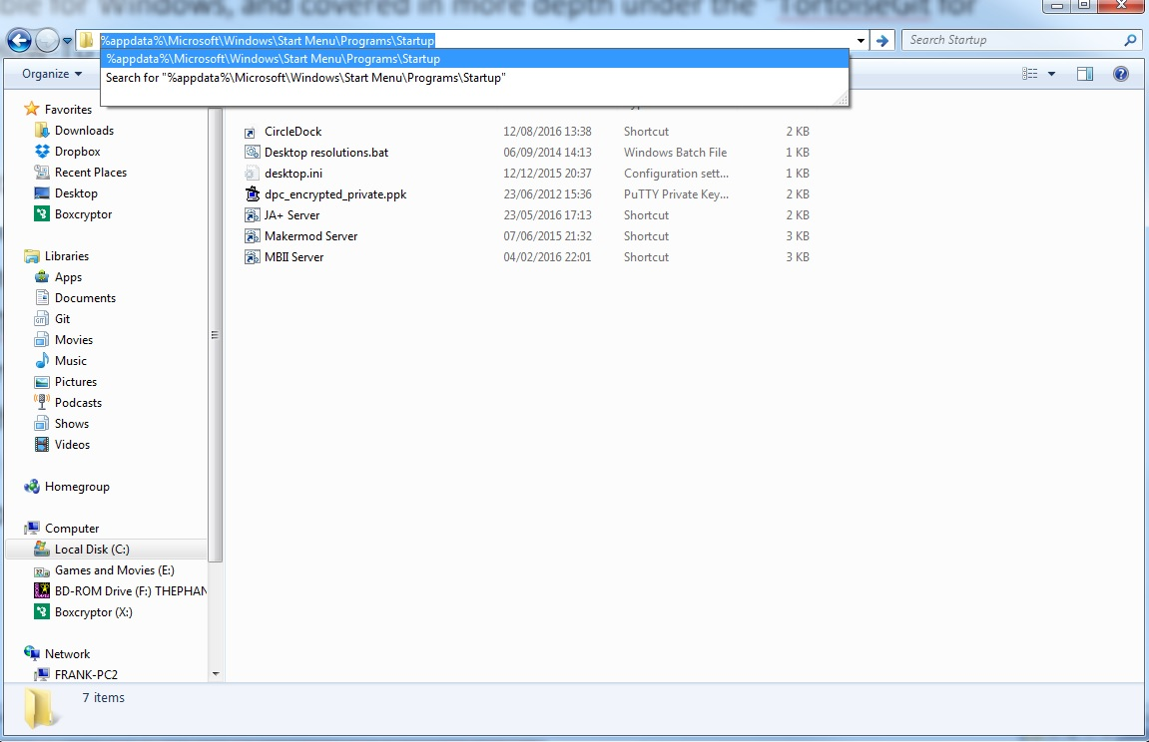

# Connecting to the Instance

## con-1

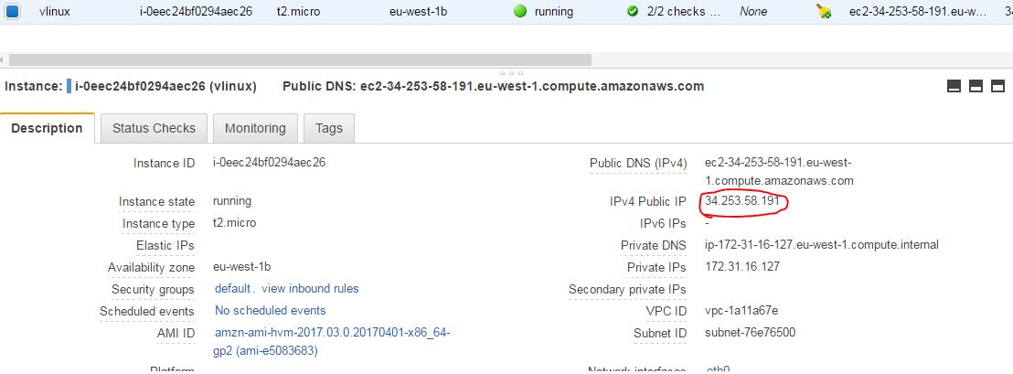

# Creating / Removing EBS Volumes

## ec2-9

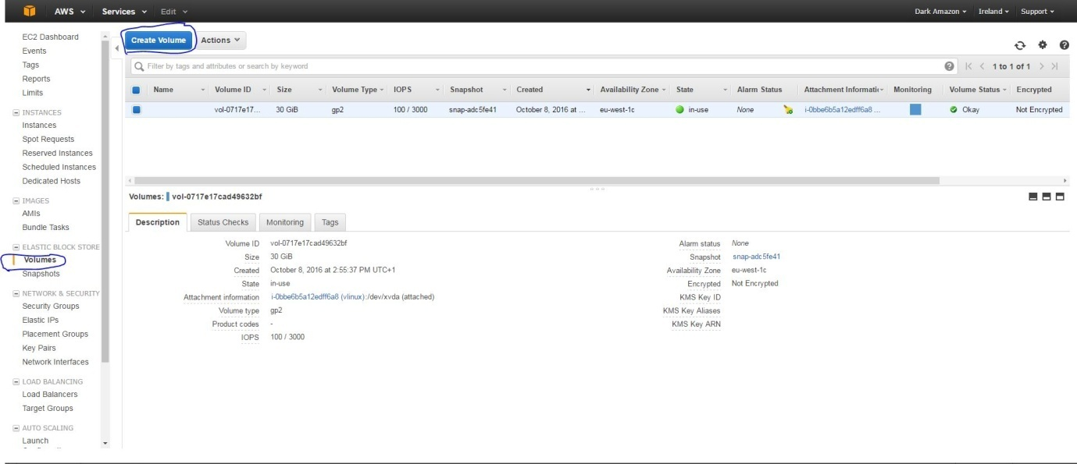

## ec2-10

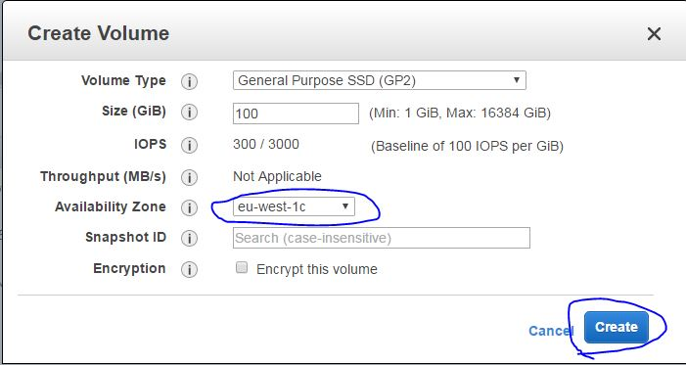

## ec2-11

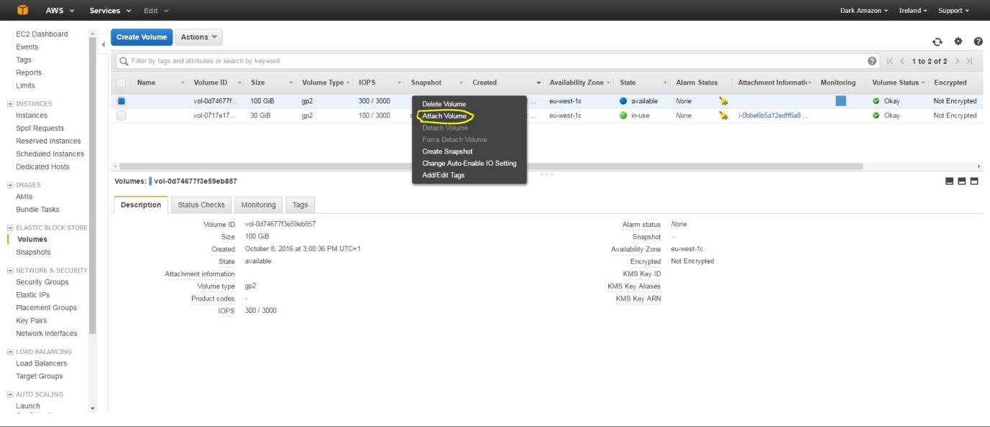

## ec2-12

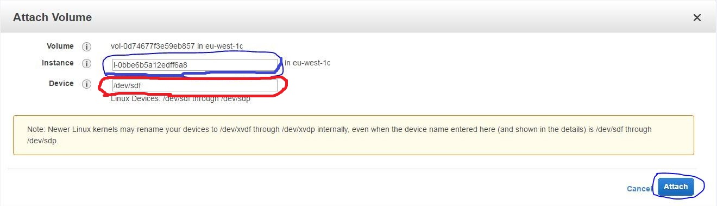

# Managing EBS Volumes

## ec2-16

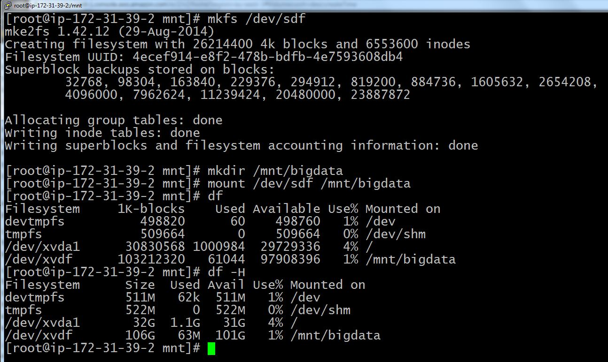

## ec2-17

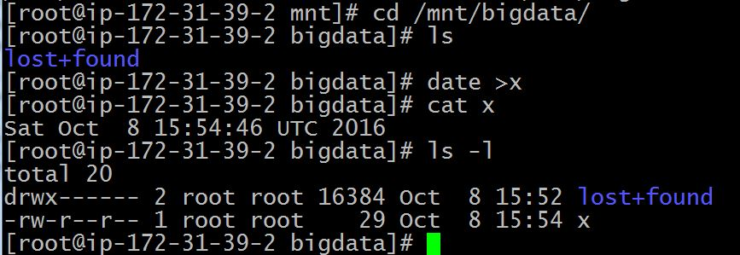

# Installing Apache and PHP, and Managing the WebServer

## pak-1

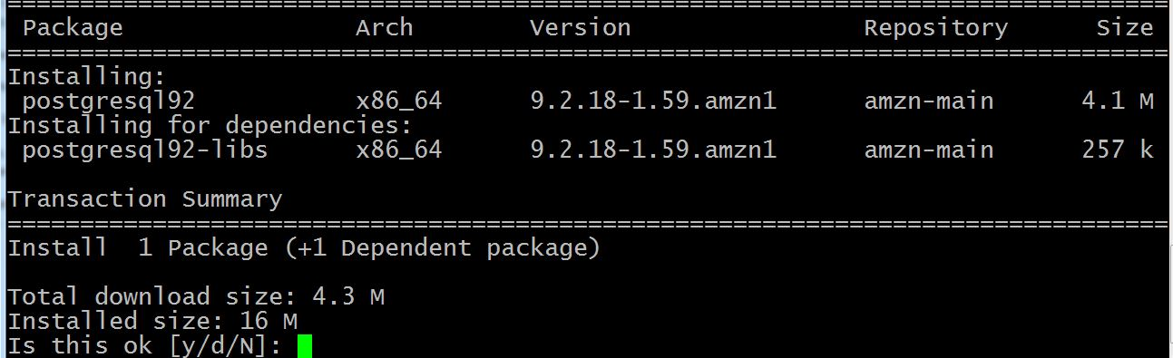

## pak-2

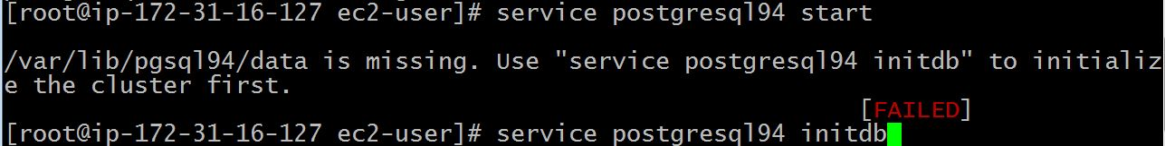

# Backup/Restore Test Data

## bak-1

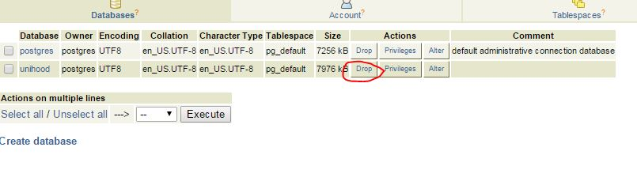

## bak-2

